BIT: Tool Rationalization Legacy Glazer's Diver Reports Transition

Business Requirements Document

Prepared by: Fernando Villaamil

Table of Contents

2 Revision History 4

2.1 Approvers 5

3 Project Overview 6

3.1 Project Scope 6

4 Business Process 7

4.1 Current (As-Is) 7

4.2 Future (To-Be) 7

4.3 As-Is / To-Be Diagram. 8

5 Functional Requirements 10

5.1 Assumptions, Dependencies, Constraints and Risks 10

5.2 Reporting Requirements 11

5.2.1 Common Reports 11

5.2.2 Data Availability Requests 17

5.3 Data Requirements 19

5.4 Miscellaneous Requirements 21

6 Non-Functional Requirements 22

7 Out of Scope 23

7.1 Functionality 23

8 Appendix 24

8.1 Terms and Abbreviations 24

8.2 User Lists 25

8.2.1 List of Users 25

8.2.2 List of Power Users by Site 25

8.3 Common Report Examples 27

8.3.1 Slotting Report 27

8.3.2 On Hand Inventory 27

8.3.3 Yesterday’s Receipts/Date of Last Receipt 27

8.3.4 Discontinued Inventory on Order 28

8.3.5 Out of Stock by Vendor at Month End 29

8.3.6 Historical Sales and Forecast 30

8.3.7 Vendor on Order Next ETA 30

8.3.8 Inventory Analysis – combining Sales & Inventory 31

8.3.9 Inventory Turns 32

8.3.10 Heavy Item Report 32

8.3.11 Points of Distribution 34

8.3.12 Accounts Sold 35

8.3.13 ABC Monthly Cust Sales (ABC Permit Report) 35

8.3.14 New Distribution/Placement Reporting 36

8.3.15 New Product Detail 36

8.3.16 Lost Product Detail 37

8.3.17 Incoming New Items 37

8.3.18 Sales Inventory by Item 39

8.3.19 Sales Report 24 Month 40

8.3.20 Sales Chain Report 24 Month 44

8.3.21 Case and Bottle Price 44

8.3.22 ZORD_Z04 44

8.3.23 MTD Gross Margin 45

8.3.24 3 Month Pricing 45

8.3.25 SAP Pricing File 46

8.3.26 Pricing Grid 46

8.3.27 12176 Default Pricing (Everyday Discount) 47

8.3.27 12176 Group Pricing (Off-Premise Discount) 47

8.3.28 ZCOST – Margin Report (SAP) 48

8.3.29 ZOR101012176 – Support Agreement GOA and BANK Report 48

8.3.30 Order Delivery Report 48

8.4 Data Availability Requests Examples 49

8.4.1 Inventory Report 49

8.4.1 Gross Profit 49

8.4.2 Salesman Hierarchy 50

# Revision History

The Revision History table records significant changes to the business requirements document inclusive of project scope, objectives, cost, risk, design, organization and schedule. The document will be reviewed with both clients and project team regularly through the project life cycle.

| Version | Date  Changed | Revised By | Revision Details/Reason |
| --- | --- | --- | --- |
| 1.0 | 09/11/2018 | F.Villaamil | Initial Draft |
|  |  |  |  |
|  |  |  |  |
|  |  |  |  |
|  |  |  |  |

## Approvers

Sign-off indicates that the approver is formally speaking on behalf of his/her business unit and indicating that the requirements presented in the Business Requirements Document have been agreed-to by the business unit and are accurate and comprehensive.

|  |  |  |  |
| --- | --- | --- | --- |
| Name | Email and Title | Approval Date | Version |
| Ann Burns | [ABurns@sgws.com](mailto:ABurns@sgws.com) Director - Accounting Projects, TX |  |  |
| Louis Zweig | [LZweig@sgws.com](mailto:LZweig@sgws.com) SVP Supplier Management - TX |  |  |
| Gary Schwartz | [Gschwartz@sgws.com](mailto:Gschwartz@sgws.com) VP-State, TX |  |  |
| Chris Harris | [ChristopherJ.Harris@sgws.com](mailto:ChristopherJ.Harris@sgws.com)  VP- Regional Finance, MO |  |  |
| Randy Myers | [RMyers@sgws.com](mailto:RMyers@sgws.com) Senior VP – State, MO |  |  |
| Johnny Licciardi | [Johnny.Licciardi@sgws.com](mailto:Johnny.Licciardi@sgws.com) Senior VP, LA |  |  |
| Brian Drobik | [BDrobik@sgws.com](mailto:BDrobik@sgws.com) VP, Commercial Operations, OH |  |  |
| Steve Ryan | [richard.ryan@sgws.com](mailto:richard.ryan@sgws.com) VP - Regional Finance, AR |  |  |
| Matt Xhemajli | [MattXhemajli@sgws.com](mailto:MattXhemajli@sgws.com) Enterprise Technology Innovation Manager, |  |  |
|  |  |  |  |

# Project Overview

## Project Scope

With the implementation of the OneSAP project, Legacy Glazer's data will no longer be sent to the Legacy Glazer's Diver environment. The goal of this project is to bridge the Legacy Glazer’s internal users reporting gap, which is being introduced via the OneSAP migration. Specifically, this project will ensure the successful transition of the Legacy Glazer Internal DIVER reporting to OneSource.

To achieve this the following will take place:

* Transition out of DIVER the Legacy Glazer's common reports as defined in Section 5.2 of this BRD.
* The required reporting source data elements previously accessed via Diver will be transitioned to OneSource. Any data gaps that cannot be addressed will be handled via alternate solutions.
* Internal users will be trained in the selected reporting tools.
* The solutions will be implemented in all Legacy Glazer States – Kansas, Texas, Missouri, Oklahoma, Louisiana, Arkansas, Ohio and Iowa.

# Business Process

## Current (As-Is)

Glazer’s Diver environment contains interactive reports available on a 24/7 basis and updated daily.

The Legacy Glazer Diver Environment is loaded from SAP via the AS/400. The AS/400 is used for transforming the SAP data extracts to DIVER load files and does not play any other functions on the load process

* SAP sends files to the AS/400. There are no ‘scripts’ that send data directly from SAP to Diver
* The AS/400 then runs programs to load these files to the staging tables.
* After that process is complete other programs use the staging tables to create the files that are send to Diver via FTP.

The Diver Reporting environment includes:

* Diver – used for Internal and External Supplier Sales Reports
* ProDiver/Citrix-Diver – for internal users to create and save markers
* Broadcast – allows users to automatically send markers to their email as PDF or Excel files
* Diveport – an online reporting tool for select Suppliers
* Planner (for creation and manipulation of Supplier goals)
* CellDiver (Diver functionality within Excel, used to create trackers)

The Sales reports can be viewed in a variety of data metrics. They include analysis by Report Code, Item, State, Warehouse, and Customers and they report information in a variety of time periods available such as vendor fiscal, rolling 12 months, Thus Year vs Last Year and This Month, same Month Last Year vs Last Month, same Month Last Year.

Other available reports handle Operations and Supply Chain Management.

The reports can be saved as PDFs or downloaded to Excel, where the information can be manipulated.

## Future (To-Be)

As part of this project all common reports listed in Section 5.2 of this BRD will be transitioned out of DIVER. The required source data elements for these reports previously accessed via Diver will be transitioned to OneSource.

If there are any data gaps (identified in section 5.3 Data Requirements) that cannot be addressed, they will be handled via an alternate solution.

## As-Is / To-Be Diagram.

**AS-IS**

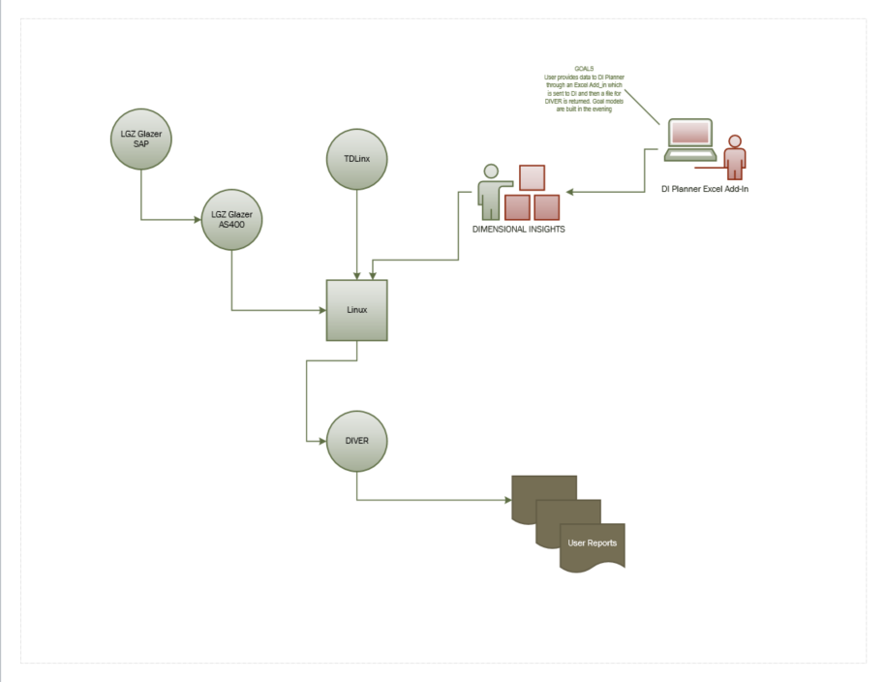

**TO-BE**

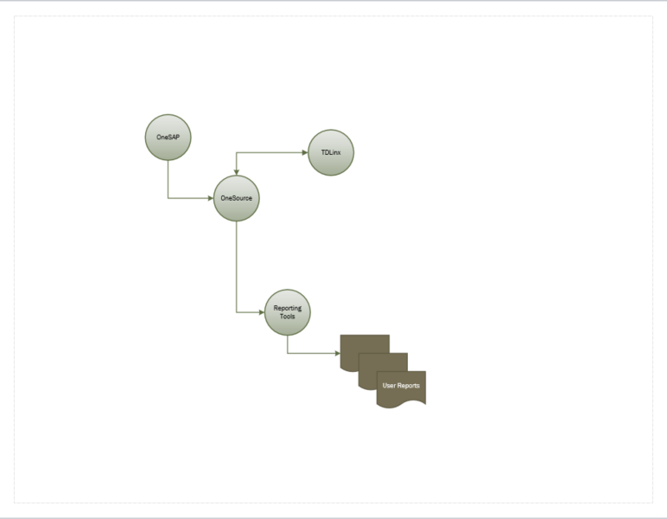

# Functional Requirements

## Assumptions, Dependencies, Constraints and Risks

A – Assumption: accepted as true or as certain to happen

D - Dependency

C – Constraint: a limitation or restriction

R – Risk: threat of any negative occurrence

|  |  |  |  |
| --- | --- | --- | --- |
| ID | ADCR | RISK AREA | Description |
| ADCR_030 | A | Reporting | For each DIVER site the following will be identified:   * List of users impacted by the change * Reporting SME/s for each site * The SME’s that will be involved in UAT testing * Scope of training required – reporting tool, online, webinar, onsite, etc. |
| ADCR_031 | R | Reporting | There is no Technical Developer at SGWS for DIVER. |
| ADCR_032 | R | Reporting | The logic/code used to generate the DIVER reports is not known. |
| ADCR_031 | R | Reporting | There is no Technical Developer at SGWS for DIVER. |
| ADCR_120 | A | Data Needs | All data currently used by DIVER will be in OneSource |
| ADCR_121 | A | Data Needs | Historical Data for Legacy Glazer DIVER will be available after 9/4 |
| ADCR_122 | A | Data Needs | Any data not brought in to OneSource by the OneSAP project but required for this project must be addressed. This scope will require ABAP programmers. |
| ADCR_140 | A | Miscellaneous | Business Objects (Webi) will be the preferred reporting tool |
| ADCR_141 | R | Miscellaneous | ETP QA lacks experience with Diver. |
|  |  |  |  |

## Reporting Requirements

### Common Reports

#### Operations

| ID | Priority | Description | Approver |
| --- | --- | --- | --- |
| REQ_030 |  | Slotting Report  See Common Report Examples Slotting Report  Warehouse slotting is defined as the placement of products within a warehouse facility. Its objective is to maximize the use of a warehouse's available cube space by improved storage and picking efficiency and reductions in warehouse handling costs by optimizing product locations. Slotting Report identifies the product locations.  This report is at the item level and is about cases and bottles primary location and pick quantity and frequency YTD-MTD, R12 TY | Phani Gadiraju |
| REQ_031 |  | On Hand Inventory Report  See Common Report Examples On Hand Inventory  On hand inventory by item with inventory locations and pick metrics.  This report is at the item level and is about cases and bottles primary location and pick quantity and frequency YTD-MTD, R12 TY | Phani Gadiraju  Michael Slater |
| REQ_032 |  | Yesterday’s Receipts/Date of Last Receipt Report  See Common Report Examples Yesterday’s Receipts/Date of Last Receipt  Yesterday’s receipts by item with MTD totals.  This report is by state and shows items, vintage, yesterday receipts, vendor receipts current month and regular cases on hand:  Yesterday Receipts Definition: RCV_CASES by INVENTORY_DT_SK (for yesterday) | Phani Gadiraju  Michael Slater |
|  |  |  |  |

#### Supply Chain Management

| ID | Priority | Priority | Approver |
| --- | --- | --- | --- |
| REQ_050 |  | Discontinued Inventory on Order Report  See Common Report Examples Discontinued Inventory on Order  The report identifies items on order that that are no longer available to be issued. The report needs “material status flag”. This report lists item description, item number, vintage, cases on hand, lading cost, on hand cost, last six months sales, vendor on order and avg sales in the last 12 months for state discontinued D_ITEM.status = 'D’. | Lisa Ligon |
| REQ_051 |  | Out of Stock by Vendor at Month End Report  See Common Report Examples Out of Stock by Vendor at Month End  Report identifies out of stock items. This report is at Warehouse and Programmer level and displays all vendors out of stock totals as well as cases sold LMTY/LMLY and R12  Out of Stock definition needs to be validated and agreed upon. The LGZ and Southern definitions are different. | Lisa Ligon |
| REQ_052 |  | Historical Sales & Forecast Report  See Common Report Examples Historical Sales and Forecast  This report is at the item level and is about cases sold YTD, LYTD, R12, MTD, same month last year, regular on hand and vendor on order | Dave Christenson |
| REQ_053 |  | Vendor on Order Next ETA Report  See Common Report Examples Vendor on Order Next ETA  This report is at the item level and is about cases on hand, inventory on order and open purchase orders, next delivery date ETA, cases and dollars with current On-Hand. | Dave Christenson  Louis Zweig |
| REQ_054 |  | Inventory Analysis Report  See Common Report Examples Inventory Analysis – combining Sales and Inventory  Report is at the site level as well By Programmer TY vs LY and TM vs LM cases, out of stock cases and on hand/order cases, days on hand, and $ including sales totals and variances MTD & YTD sales in Cases and dollars.  Showing days on hand(DOH) and inventory turns metrics. | Katie and  Dave Christenson  Michael Slater |
| REQ_055 |  | Inventory Turns Report  See Common Report Examples Inventory Turns  This report shows Turns cases by State LM/LMLY. Turn cases are: Sales last month/{(first day on hand last month + last day on hand last month)/2} . | Dave Christenson |
|  |  |  |  |

#### Sales

|  |  |  |  |
| --- | --- | --- | --- |
| ID | Priority | Description | Approver |
| REQ_070 |  | Points of Distribution Report  See Common Report Examples Points of Distribution  This report is for sold and unsold periods by salesman, customer and brand. It counts distinct ITEM_NO and CUSTOMER_NO by BRAND. Count of customers sold by sales rep. | Ann Burns |
| REQ_071 |  | Accounts Sold Report  See Common Report Examples Accounts Sold  This report is by vendor 9L cases sold YTD, LYT , LY, TM and counts number of distinct customers that sold these items YTD, LYT, variance, 90 days, 180 days TY and LY. Count of customers sold by brand for specified supplier compared to last year for multiple period ranges. | Louis Zweig  Michael Slater  Ashley Litton |
| REQ_072 |  | ABC Monthly Cust Sales Report  See Common Report Examples ABC Monthly Cust Sales (ABC Permit Report)  This report is a list of customers, their addresses and Permit number as well as permit expiration date, customer status and total last sales completed. | Michael Slater |
| REQ_073 |  | New Distribution Report  See Common Report Examples New Distribution/Placement Reporting  This report is for sold and unsold periods by supervisor, salesman, item and customer. It contains incentive payouts. It is used for product placement in an account. | Ann Burns |
| REQ_074 |  | New Product Detail Report  See Common Report Examples New Product Detail  New Product Detail. Shows On-Hand cases and $ LMTY/LMLY and variances for New Products. Lists products this year that we did not have last year.  New Product data is defined as follows:   * "Days Since First Received" = today()-Info[_State First Received Date_] * "New" = Days Since First Received < 181 * "New and Slow Intro" = Days Since First Received<181 And 5% of On Hand Cases > Last 12 Months+MTD Cases | Amy Burgess  Bill Jansen |
| REQ_075 |  | Lost Product Detail Report  See Common Report Examples Lost Product Detail  Lists products last year that we don’t have this year. Lost Product Detail. Shows On-Hand cases and $ LMTY/LMLY and variances for Lost Products. | Amy Burgess  Bill Jansen |
| REQ_076 |  | Incoming New Items Report  See Common Report Examples Incoming New Items  List new items with totals cases on order, last received date and next eta with cases. This reports lists items that have not been sold before (new items) and there is a variant for Slow intro items. It lists vintage, state status, on hand cases, intercompany in transit and intercompany on order, vendor on order cases and days since first received by warehouse and programmer. | Dave Christenson |
| REQ_077 |  | Sales & Inventory by Item Report  See Common Report Examples Sales Inventory by Item  Report is at the item level and includes vendor cases on order, intercompany in transit, manual plan cases and unsale cases TY, LY, TM,12 and rolling 12 months. | Louis Zweig  Michael Slater  Ashley Litton |
| REQ_078 |  | 24 Month Sales Report based on supplier fiscal year  See Common Report Examples Sales Report 24 Month  This report is a R12 report comparing TY vs. LY and variances based on Vendor Fiscal Month by Vendor listing standard cases, 9L and Net cases. | Louis Zweig  Michael Slater  Ashley Litton |
| REQ_079 |  | 24 Month Sales Report based on calendar year. Same as “24 Month Sales  Report based on “supplier fiscal year” but by calendar year rather than fiscal year.  Rolling sales report based on calendar year - current year vs last year by specified grouping and month. | Louis Zweig  Michael Slater  Ashley Litton |
| REQ_080 |  | Sales Chain Report (24 Month)  See Common Report Examples Sales Chain Report 24 Month  This report measures chain performance on cases sold TY/LY, variance, YTD and by month based on calendar date | Ann Burns |
| REQ_081 |  | Case and Bottle Price Report  See Common Report Examples Case and Bottle Price  Front line case and bottle price by item for selected supplier and state. | Michael Slater |
| REQ_082 |  | ZORD Z04 Report  See Common Report Examples ZORD_Z04  This is a report by order number and shows vendor, customer, item, requested delivery date, cases ordered. | Chris Harris |
| REQ_083 |  | MTD Gross Margin Report  See Common Report Examples MTD Gross Margin  Gross profit report by vendor with supplier participation and sales metrics. Report shows MTD net sales before brokerage, COG, Promos and Gross Margin MTD, SMLY, average case price MTD, number of cases sold and variances.  **Note: This report is dependent on pricing data being brought into OneSource from SAP. It will be delivered as part of the Pricing workstream.** | Michael Slater  Ashley Litton |
| REQ_084 |  | 3 Month Pricing Report  See Common Report Examples 3 Month Pricing  List price and current price by item for current month and next month with sales for last three months, inventory on hand and inventory on order.  **Note: This report is dependent on pricing data being brought into OneSource from SAP. It will be delivered as part of the Pricing workstream.** | Chris Harris  Carol Burns |
| REQ_085 |  | Pricing Structure Report  See Common Reports Examples SAP Pricing File  Item cost and pricing details for all pricing levels.  With inventory totals by warehouse location. General Product Info by Vendor. Pricing discount levels, profit, margins, cases, dollars by WH, trends and TY/LY aggregations.  **Note: This report is dependent on pricing data being brought into OneSource from SAP. It will be delivered as part of the Pricing workstream.** | Ann Burns |
| REQ_086 |  | Pricing Grid Report  See Common Reports Examples Pricing Grid  This report is by Vendor and lists items, QD start and end dates, group deals discounts, level, status. Warehouse and material number, case qty, discounts, future charges, bottle and pack UPC and inner UPS  **Note: This report is dependent on pricing data being brought into OneSource from SAP. It will be delivered as part of the Pricing workstream.** | Ashley Litton |
| REQ_087 |  | 12176 Default Pricing (Everyday Discount)  See Common Reports Examples 12716 Default Pricing (Everyday discount).  **Note: This is also referred to as the Every Day Discount report.**  **Note: This report is dependent on pricing data being brought into OneSource from SAP. It will be delivered as part of the Pricing workstream.** | Evelyn Dubois |
| REQ_088 |  | 12176 Group Pricing.  See Common Reports Examples 12176 Group Pricing  Group Type SKU Deals discount report  **Note: This report is dependent on pricing data being brought into OneSource from SAP. It will be delivered as part of the Pricing workstream.** | Evelyn Dubois |
| REQ_089 |  | ZCOST  See Common Reports Examples ZCOST Margin Report  This report is at the item level and it displays cost metrics and margin  **Note: This report is dependent on pricing data being brought into OneSource from SAP. It will be delivered as part of the Pricing workstream.** | Evelyn Dubois |
| REQ_090 |  | ZOR101012176  See Common Reports Examples ZOR101012176  This report displays item by distribution channel and vendor. GOA is the money that vendor put in a bank to support marketing effort.  **Note: This report is dependent on pricing data being brought into OneSource from SAP. It will be delivered as part of the Pricing workstream.** | Evelyn Dubois |
| REQ_091 |  | Order Delivery Report  See Common Reports Examples Order Delivery Report  This report shows the items, document type, delivery qty (total cases), vendor samples 50%,100%, customer samples and house samples and a calculated column for results  Note: F_SALES and F_ORDERS – Samples are document types | Renee Lawrence |
|  |  |  |  |

### Data Availability Requests

|  |  |
| --- | --- |
| ID | Description |
| REQ_100 | Master Data Report - Customer & Material (Louis Zweig TX).  Note: TBD - Needs Example |
| REQ_101 | Master Data Universe (Lisa Ligon). Whether or not they have transactional data is TBD  There isn’t one report we need to include this data. The request is for a Universe to be built that includes sales and inventory for ALL items, ALL customers, and ALL salesperson, programmer/portfolio manager (Brand Manager) regardless of whether there is transactional data or not. This is so we can build reports with custom columns specific to an item/customer/rep/etc. BEFORE there is transactional data, so the column would begin to populate in the report as soon as there are sales. This is preferable to having to wait until there are sales to build the report. |
| REQ_102 | Pricing Structures (Louis Zweig TX) |
| REQ_103 | Inventory: by branch, on hand, on order, arrival, FOB, next 90 days, last 90 days (Louis Zweig TX) |
| REQ_104 | Programmers in each state by supplier (Louis Zweig TX) |
| REQ_105 | 24 month stacked reports on cases (Louis Zweig TX) |
| REQ_106 | Accounts sold by report code & size (Louis Zweig TX) |
| REQ_107 | Column on profit report of LMF/BDF; margin pre- & post LMF/BDF (Louis Zweig TX) |
| REQ_108 | Sales last 90 days combined with forecast next 90 days by branch (Louis Zweig TX) |
| REQ_109 | Sales & Inventory by Item (Michael Slater LA).  See Data Availability Requests Examples Inventory Report  This report is by WHS, Report Code Programmer, Major Class and shows order pad number state, material number and description, vintage, manu plan cases (Planned are the items that are forecasted and ordered by JDA. Unplanned means the market managers will oversee the ordering manually). Then it shows cases on hand, vendor cases on order and sales for MTD, Last 3,6 and 12 months.  Note: This is a variation of the Common Report Sales and Inventory by Item |
| REQ_110 | Gross Profit (Renee Lawrence TX).  See Data Availability Requests Examples Gross Profit  This report is by WHS state, WHS and vendor and it displays Sales less broken cases, promo, margin, variances, case price TY/LY/R12.  Note: This is a variation of the Gross Margin Report.  **Note: This report is dependent on pricing data being brought into OneSource from SAP.** |
| REQ_111 | Salesman Hierarchy (Nicholas Wood – OH).  See Data Availability Requests Examples Salesman Hierarchy  This request revolves around the salesman hierarchy which is based on data for the supervisor of the salesman and the subsequent supervisory levels.  **Note: The below shows the Ohio Salesman Hierarchy as opposed to the Arkansas Hierarchy.** |
|  |  |

## Data Requirements

| ID | Description | Report Reference |
| --- | --- | --- |
| REQ_120 | This is the list of fields that currently OneSource does not have and which are needed to generate some of the common reports.   * PROGRAMMER * MANU PLAN CLASS * INTERCO ON ORDER QTY * INCENTIVE PAYOUT * REQ.DLV.DT * PERMIT # * PERMIT EXPIRATION      * ALL MISSING IN TABLE F_PURCHASE_ORDERS * CASES_IN_TRANSIT (from Table AGG_INVENTORY_EOPP) * RACK_CASE_LOC (from Table F_INVENTORY) * BULK_CASE_LOC (from Table F_INVENTORY) * BOTTLE_LOC (from Table F_INVENTORY) * REGION_BUSINESS_CENTER_ID (from Table D_SALESPERSON) * DIVISION_BUSINESS_CENTER_ID (from Table D_SALESPERSON) * TEAM_BUSINESS_CENTER_ID (from Table D_SALESPERSON) | All Reports |
| REQ_121 | The solution will have the capability to provide, for the common reports listed in this BRD, the same Sales Report metrics as the ones being generated by DIVER   * BATF * 9L * CE (Case Equivalents) * Flat Cases. * Standard Cases * Analysis by Report Code, Item, State, Warehouse, and Customers.   Supply Chain Management needs specifications for the 9L & BATF conversion factor  For political buys or forward buy requests for larger suppliers, a DOH analysis is required for which 9L and BATF numbers must be included. In addition, some vendors require 9L and /or BATF numbers in their reports. 9L and BATF numbers are in OneSource.  The metrics must be available in the Universe to pull as needed for any report. (9L and BATF are already available in BO Inventory and Sales Universe). E.g., 9L Conversion Factor = Gallons*3.7853/9  BATF Conversion Factor = Defined by Govt. | Supply Chain Management Reports |
| REQ_122 | The solution will provide, for the common reports listed in this BRD, the same financial information metrics provided by DIVER such as:   * Vendor Fiscal * Rolling 12 months * TY (This Year) vs LY (Last Year) - (customized time selection) * This Month, same Month Last Year vs Last Month, same Month Last Year | Sales Reports - Sales & Inventory by Item Report |
| REQ_126 | Supply Chain Management needs specifications for the Division/Order Pad/Product Groups Hierarchy.  Order Pad, like Portfolio Manager, should be an independent data element. It indexes with STATE and with VENDOR. There IS NOT a direct correlation between Order Pad and Sales Division, nor Territory, nor Team, etc., so it should not be included in the sales hierarchy currently in development. (As per Lisa Ligon).  We currently do not have Order Pad in OneSource and need to understand this data element. | Supply Chain Management Reports |
|  |  |  |

## Miscellaneous Requirements

| ID | Description |
| --- | --- |
| REQ_140 | Reporting tool licenses as well as access to the Development, UAT and Production environments will be procured as needed for all users, developers and project team members. |
| REQ_141 | The power users listed in Section 8.3 will be trained on the tools and data sources. Training is a part of this project and we will follow the existing process in place by the PMO to request training resources. |
|  |  |

# Non-Functional Requirements

This section lists the Non-Functional Requirements for the project.

| ID | Description |
| --- | --- |
| NFR_001 | The reporting solution shall accommodate 1580 users concurrently |
|  |  |

# Out of Scope

## Functionality

|  |  |
| --- | --- |
| ID | Description |
| OOS_010 | “Standardization of reports is out of scope”.  The reports will be built as-is (i.e., as per attached examples) |
| OOS_011 | HANA Reporting. |
| OOS_012 | Business Objects (BO) Analysis - Excel Plug-In. |
| OOS_013 | “Real Time” reporting. |
| OOS_014 | Development of Ad-Hoc reports. |
| OOS_015 | Goals Reporting (DI_Planner/Dimensional Insights). The plan for the Central Region is to track the goals totally in Excel until an Enterprise Wide solution is enabled. |
| OOS_016 | Development/Transitioning of reports outside the list of the Legacy Glazer's common reports listed ins Section 5.2 within the requirements. |
| OOS_017 | External DIVER reporting to suppliers (e.g., DIVEPORT). The VIP Project will address the supplier reporting. |
| OOS_018 | Heavy Item Report  See Common Report Examples Heavy Item Report  This report is at vendor level and shows Programmer, items, first sales < R12months as well as Overstock 12 months cases and $.  The calculation for a heavy item is as follows:  MTD Flat Cases x 6 <= On Hand Cases and On Hand Cases >=0.01 and State Agg GOA_ >=1  and not Last 6 Months Case Sales >= On Hand Cases andd Days Since First Received >90  and Days Since Last Received >90 and not (Major Class Code=7 and (NotEmpty(Category Class)) |

# Appendix

## Terms and Abbreviations

|  |  |
| --- | --- |
| Term/Abbreviation | Definition |
| ABC | Alcohol Beverage Commission |
| BO | Business Objects |
| Business Objects | SAP Business Objects BI - SAP Business Objects BI (SAP BO, also historically BOBJ) is a reporting and analytics business intelligence (BI) platform aimed at business users. It consists of many reporting applications that allow users to discover data, perform analysis to derive insights and create reports that visualize the insights. |
| DIVER or DIVER BI | Diver BI from Dimensional Insight is a business intelligence and information delivery platform |
| ETA | Estimated Time of Arrival |
| PDF | A file format that provides an electronic image of text or text and graphics that looks like a printed document and can be viewed, printed, and electronically transmitted. |
| R12 | Rolling 12 Months |
| BI HANA | Business intelligence (BI) on SAP HANA, leveraging it both as a data source and as a platform. SAP Business Objects BI 4.1 is optimized for SAP HANA with new features that take advantage of the speed and agility offered by SAP HANA. |
| HANA | SAP HANA is an in-memory, column-oriented, relational database management system developed  and marketed by SAP SE. Its primary function as a database server is to store and retrieve data as requested by the applications. In addition, it performs advanced analytics (predictive analytics,  spatial data processing, text analytics, text search, streaming analytics, graph data processing) and includes ETL capabilities as well as an application server. |
| Webi | SAP Webi - Web Intelligence is part of SAP Business Objects product suite and is used for analytical and ad hoc reporting to meet an organization’s business requirements. Web Intelligence is a Business Intelligence reporting tool for business users to analyze data in Data Warehouse. It assists business managers in the decision-making process for building future strategies.  Using Web Intelligence, business users can create basic, medium, and complex reports from transactional data in database and by creating Universes using Information Design Tool/UDT. Various SAP and non-SAP data sources can be used to create reports in Web Intelligence. SAP Business Warehouse (BW) system doesn’t require a Universe to connect to Web Intelligence tool.  Web Intelligence tool can work as a client tool of Business Objects platform and as a standalone tool for reporting. |

## User Lists

### List of Users



### List of Power Users by Site

#### Kansas

* Carol Burns [CBurns@sgws.com](mailto:CBurns@sgws.com)
* Victoria Cooksey [victoria.cooksey@sgws.com](mailto:victoria.cooksey@sgws.com)
* Chris J Harris [christopherj.harris@sgws.com](mailto:christopherj.harris@sgws.com)
* Robin Rank [Robin.Rank@sgws.com](mailto:Robin.Rank@sgws.com)
* Elizabeth Mitchell [EMitchell@sgws.com](mailto:EMitchell@sgws.com)
* Yvonne Paiz [Yvonne.Paiz@sgws.com](mailto:Yvonne.Paiz@sgws.com)

#### Louisiana

* Michael Slater [Michael.Slater@sgws.com](mailto:Michael.Slater@sgws.com)
* Juliana Purcello [Juliana.Purcello@sgws.com](mailto:Juliana.Purcello@sgws.com)
* Colin Davis-McElligatt [colin.mcelligatt@sgws.com](mailto:colin.mcelligatt@sgws.com)
* Lisa Ackoury [LAckoury@sgws.com](mailto:LAckoury@sgws.com)
* Blaine Bennett [Blaine.Bennett@sgws.com](mailto:Blaine.Bennett@sgws.com)
* Debra Hays [DHays@sgws.com](mailto:DHays@sgws.com)
* Brian Edgeworth [brian.edgeworth@sgws.com](mailto:brian.edgeworth@sgws.com)

#### Arkansas

* Emily Hubbard [Emily.Hubbard@sgws.com](mailto:Emily.Hubbard@sgws.com)
* Kim Lemmons [Kimberly.Lemmons@sgws.com](mailto:Kimberly.Lemmons@sgws.com)
* Sarah Craig [sarah.craig@sgws.com](mailto:sarah.craig@sgws.com)
* Tanya Baxter [TBaxter@sgws.com](mailto:TBaxter@sgws.com)

#### Missouri

* Lisa Ligon [LLigon@sgws.com](mailto:LLigon@sgws.com)
* Gail Bendel [GBendel@sgws.com](mailto:GBendel@sgws.com)
* Tyler Row [Tyler.Row@sgws.com](mailto:Tyler.Row@sgws.com)
* Nicole Ciocarelli [nicole.ciocarelli@sgws.com](mailto:nicole.ciocarelli@sgws.com)
* Brian Collins [Brian.Collins@sgws.com](mailto:Brian.Collins@sgws.com)
* Diana Hinchey [DHinchey@sgws.com](mailto:DHinchey@sgws.com)
* Chris J. Harris [christopherj.harris@sgws.com](mailto:christopherj.harris@sgws.com)

#### Texas

* Brock Addicks [BAddicks@sgws.com](mailto:BAddicks@sgws.com)
* Jessica Ricks - Tassell [Jessica.Tassell@sgws.com](mailto:Jessica.Tassell@sgws.com)
* Paul Hansen [Paul.Hansen@sgws.com](mailto:Paul.Hansen@sgws.com)
* Jim Henk [JHenk@sgws.com](mailto:JHenk@sgws.com)
* Matthew (Matt) Hodson [MatthewHodson@sgws.com](mailto:MatthewHodson@sgws.com)
* Janet Shawver [JShawver@sgws.com](mailto:JShawver@sgws.com)
* Gabby Villafana [Gabriela.Villafana@sgws.com](mailto:Gabriela.Villafana@sgws.com)
* Colin McElroy [Richard.McElroy@sgws.com](mailto:Richard.McElroy@sgws.com)
* Tracy Kosub [TKosub@sgws.com](mailto:TKosub@sgws.com)
* Kathleena (KC) Reneau [kathleena.reneau@sgws.com](mailto:kathleena.reneau@sgws.com)
* Markus Balderach [markus.balderach@sgws.com](mailto:markus.balderach@sgws.com)
* Jason Cottle [JCottle@sgws.com](mailto:JCottle@sgws.com)
* Josiah Samuel Unger [samuel.unger@sgws.com](mailto:samuel.unger@sgws.com)

#### Iowa

* Amy Burgess – Iowa [ABurgess@sgws.com](mailto:ABurgess@sgws.com)
* Nicholas Wood – Ohio [Nicholas.Wood@sgws.com](mailto:Nicholas.Wood@sgws.com)

#### Ohio

* Bill Jansen [William.Jansen@sgws.com](mailto:William.Jansen@sgws.com)
* Brian Drobik [BDrobik@sgws.com](mailto:BDrobik@sgws.com)
* Deb Kennison [Debbie.Kennison@sgws.com](mailto:Debbie.Kennison@sgws.com)
* Jeremy Lindsey [Jeremy.Lindsey@sgws.com](mailto:Jeremy.Lindsey@sgws.com)
* Beth Bold [BBold@sgws.com](mailto:BBold@sgws.com)
* Rebecca Thomas [Rebecca.Thomas@sgws.com](mailto:Rebecca.Thomas@sgws.com)

#### Oklahoma

* Diane Vandivort [Diane.Vandivort@sgws.com](mailto:Diane.Vandivort@sgws.com)
* Theresa Mahan [Theresa.Mahan@sgws.com](mailto:Theresa.Mahan@sgws.com)
* Llaurie Ormiston [Laurie.Ormiston@sgws.com](mailto:Laurie.Ormiston@sgws.com)

## Common Report Examples

### Slotting Report

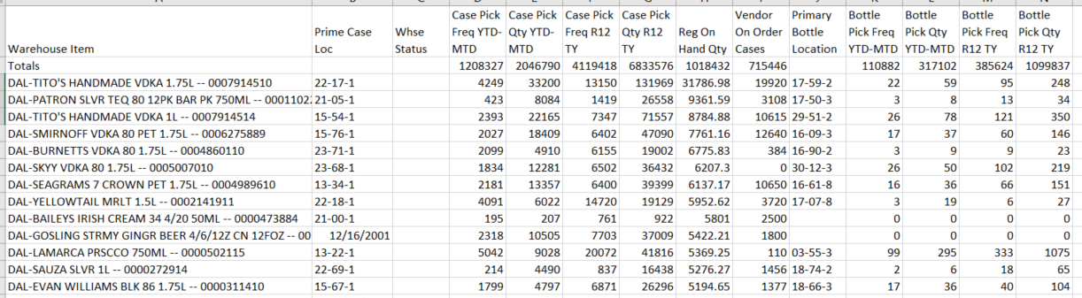

### On Hand Inventory

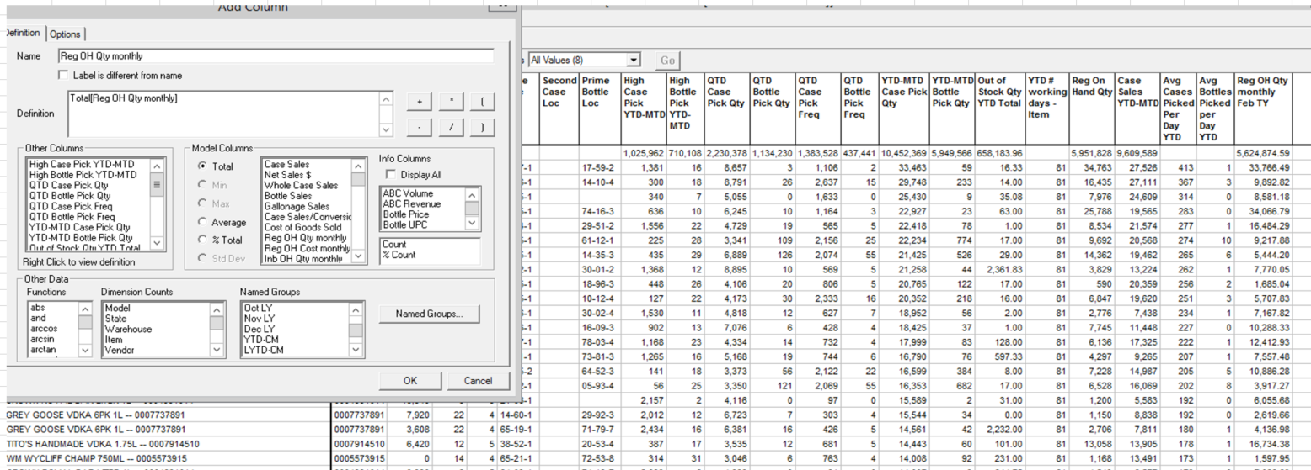

### Yesterday’s Receipts/Date of Last Receipt

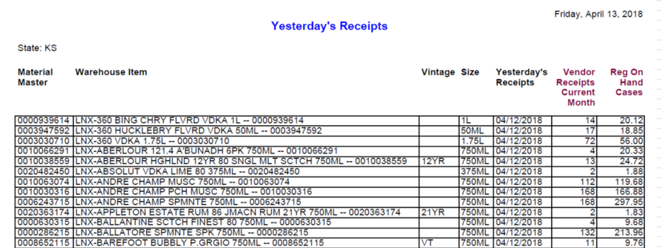

### Discontinued Inventory on Order

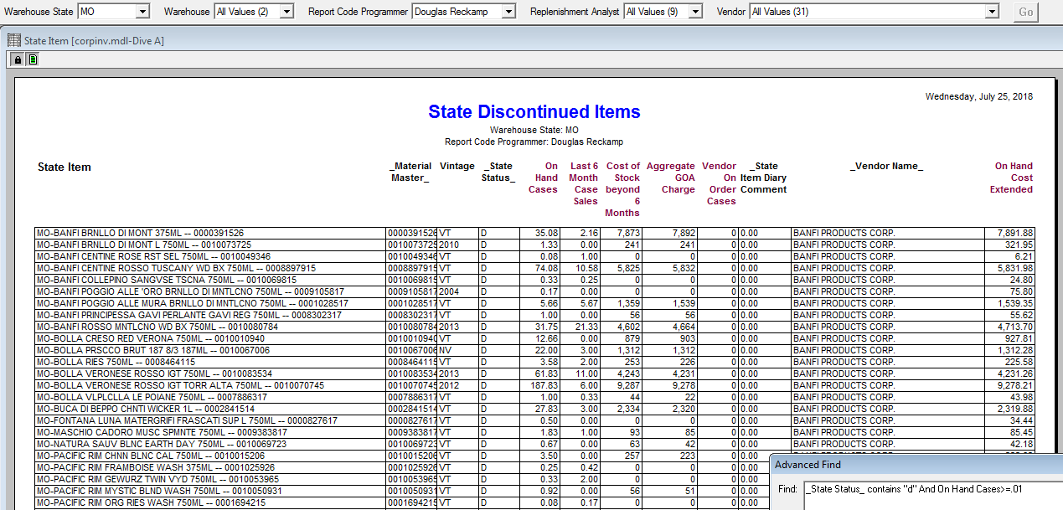

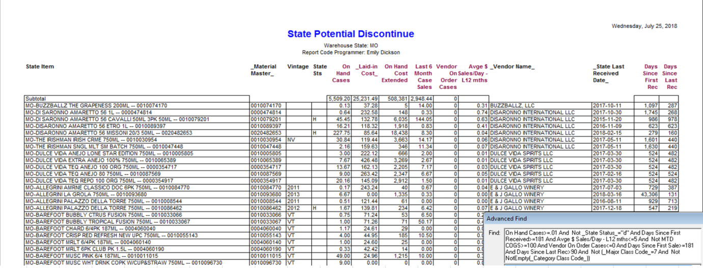

### Out of Stock by Vendor at Month End

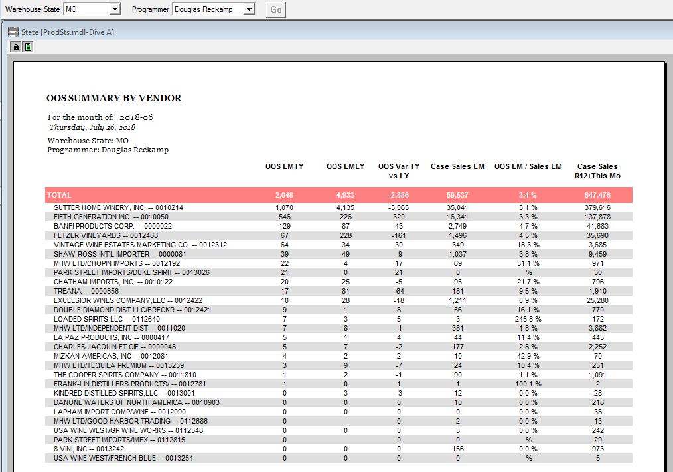

### Historical Sales and Forecast

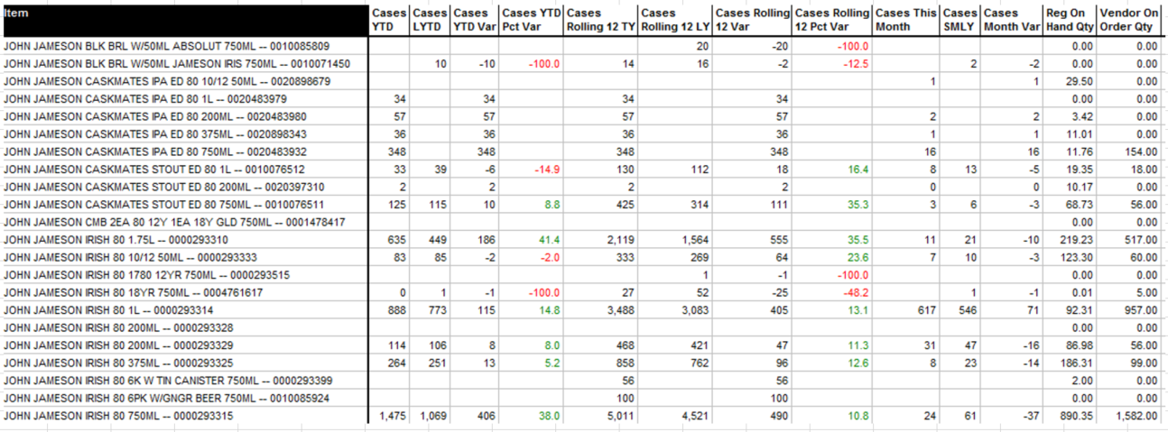

### Vendor on Order Next ETA

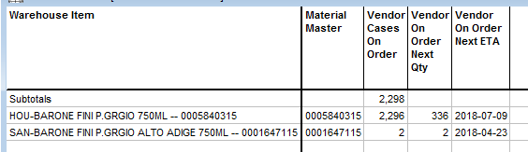

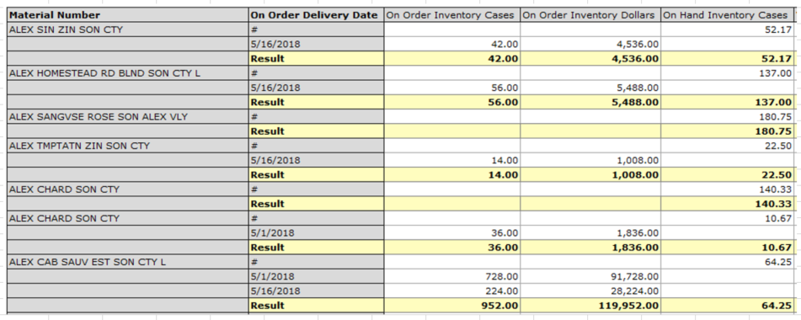

### Inventory Analysis – combining Sales & Inventory

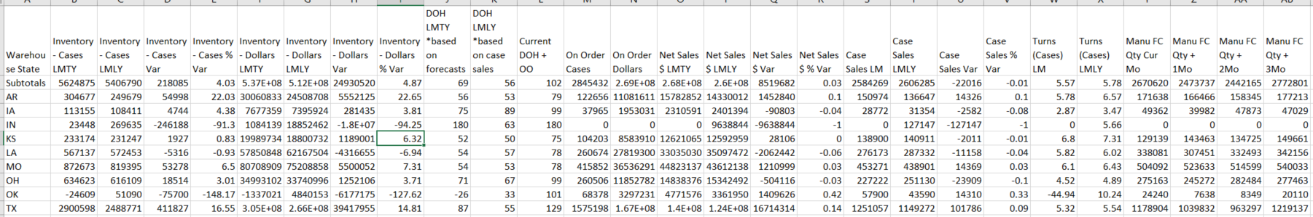

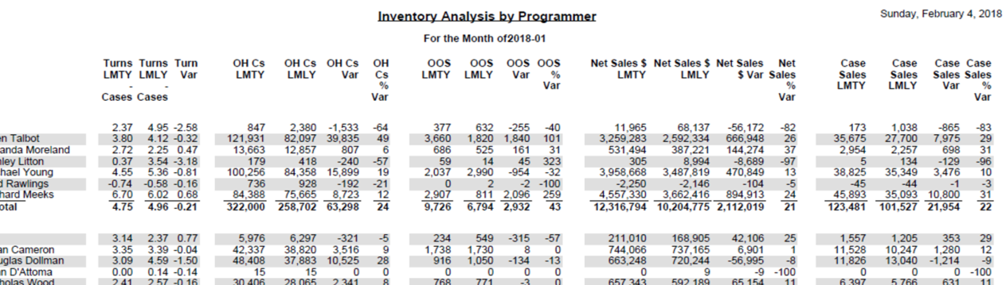

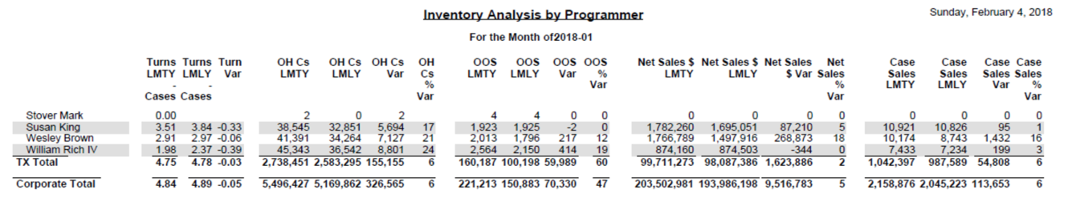

### Inventory Turns



### Heavy Item Report



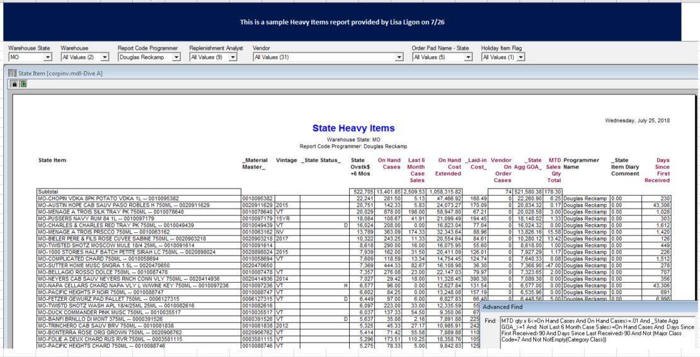

### Points of Distribution

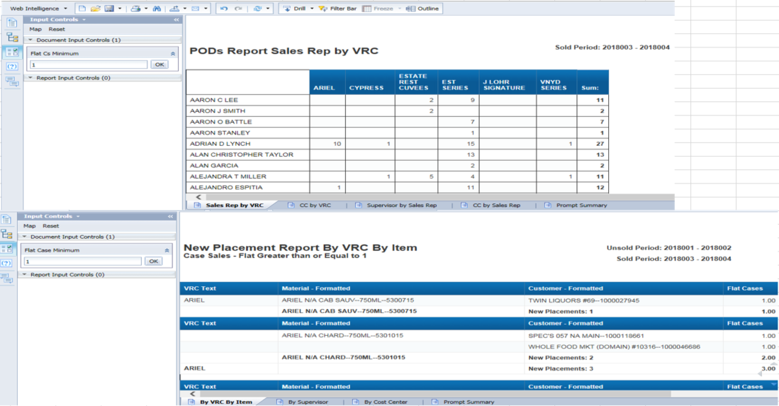

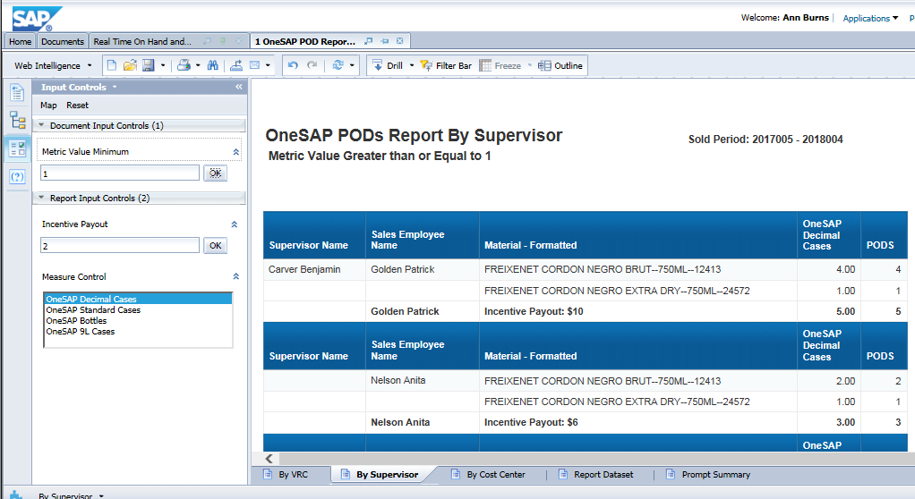

### Accounts Sold

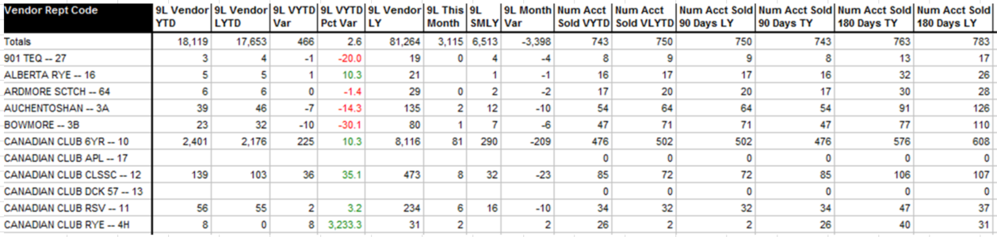

### ABC Monthly Cust Sales (ABC Permit Report)

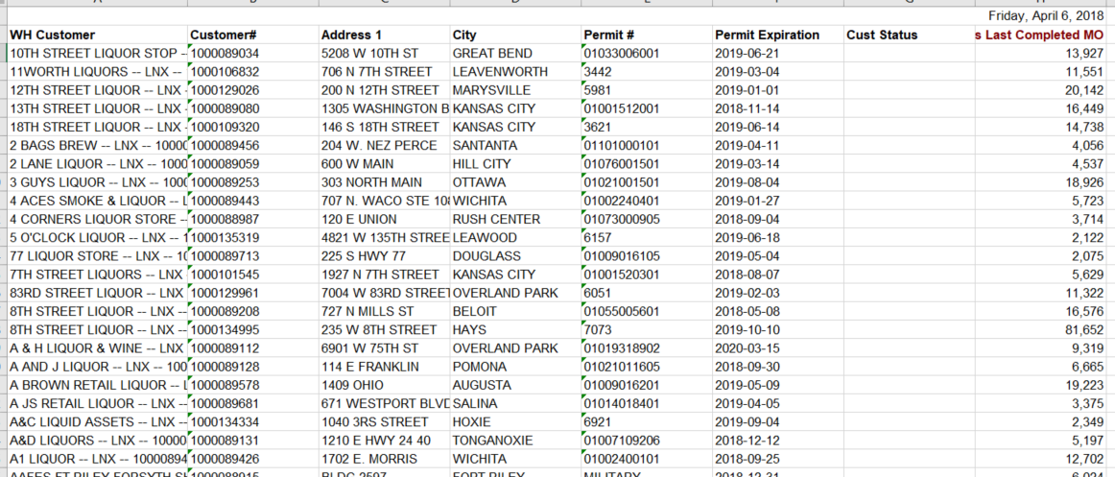

### New Distribution/Placement Reporting

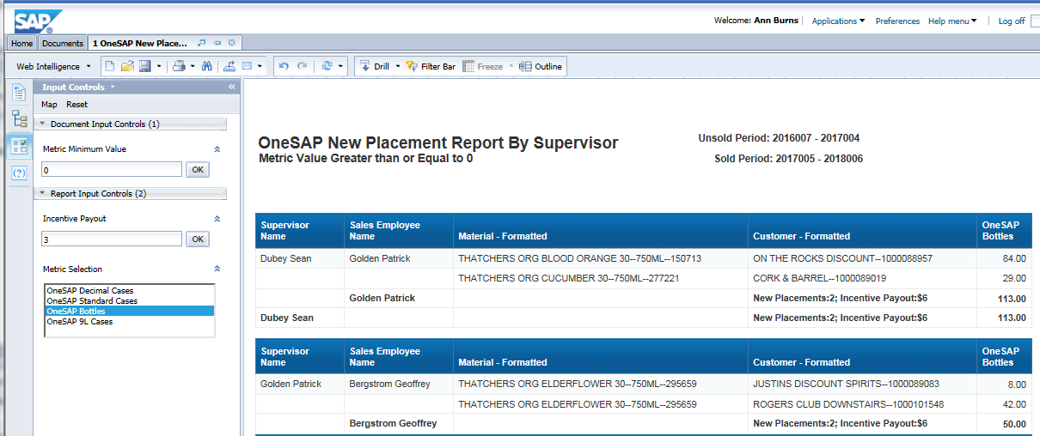

### New Product Detail

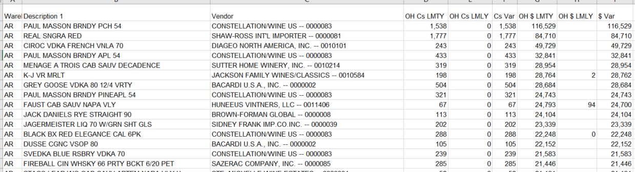

### Lost Product Detail

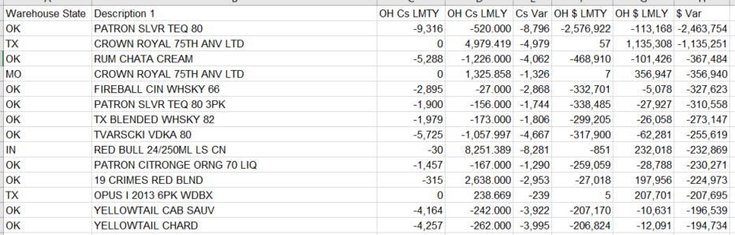

### Incoming New Items

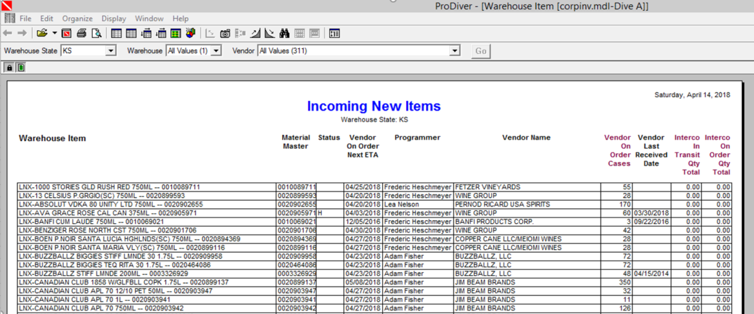

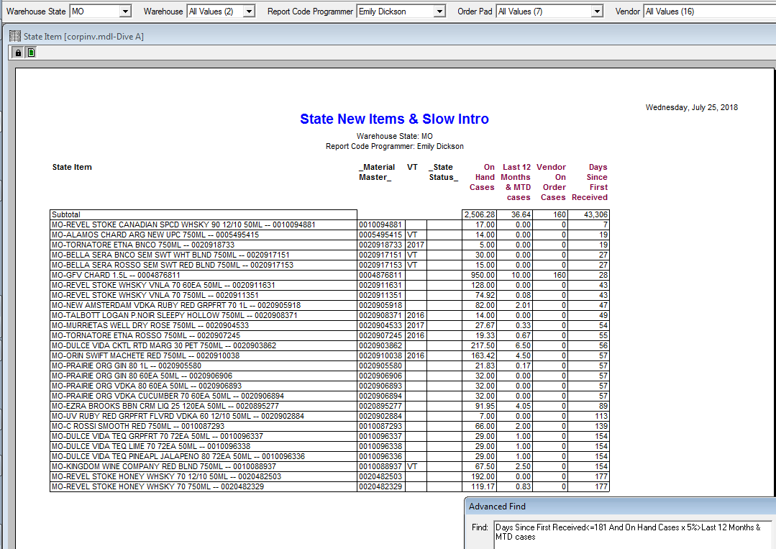

### Sales Inventory by Item

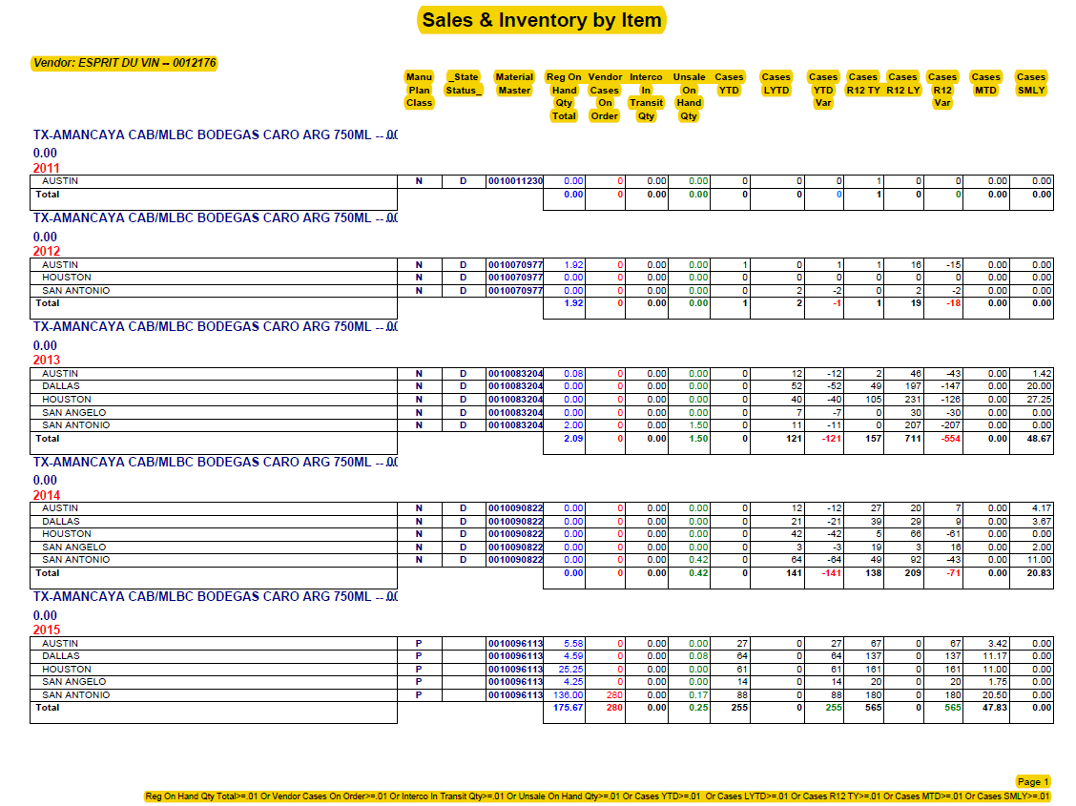

### Sales Report 24 Month

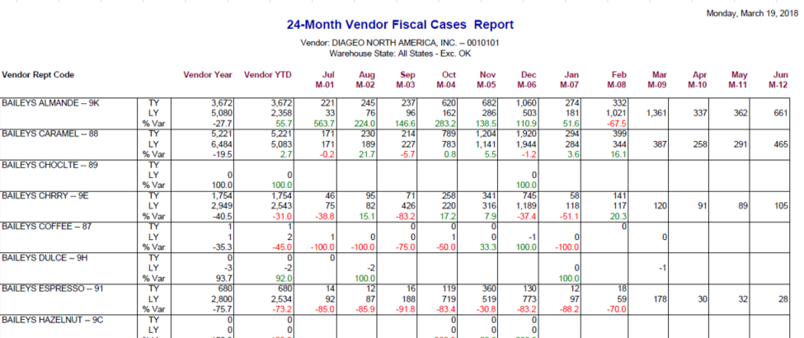

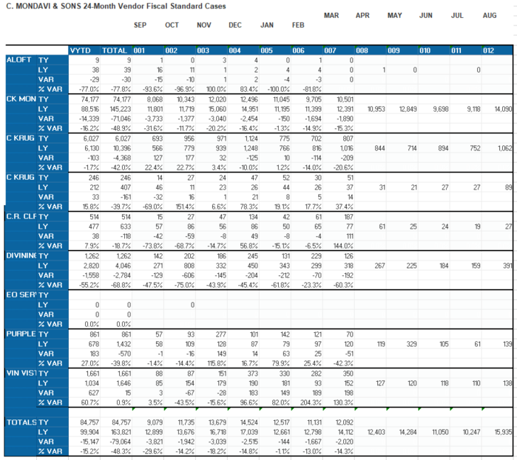

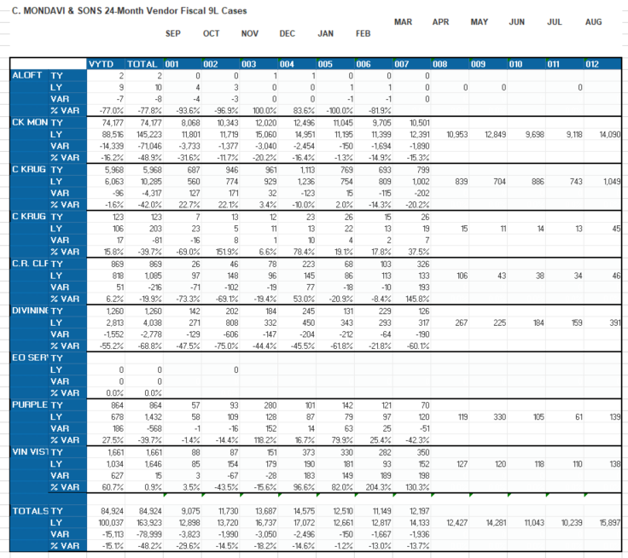

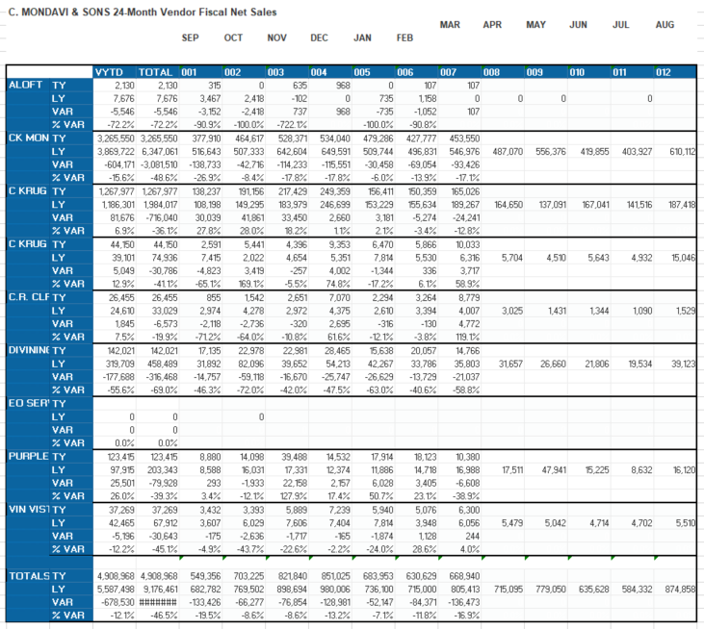

### Sales Chain Report 24 Month

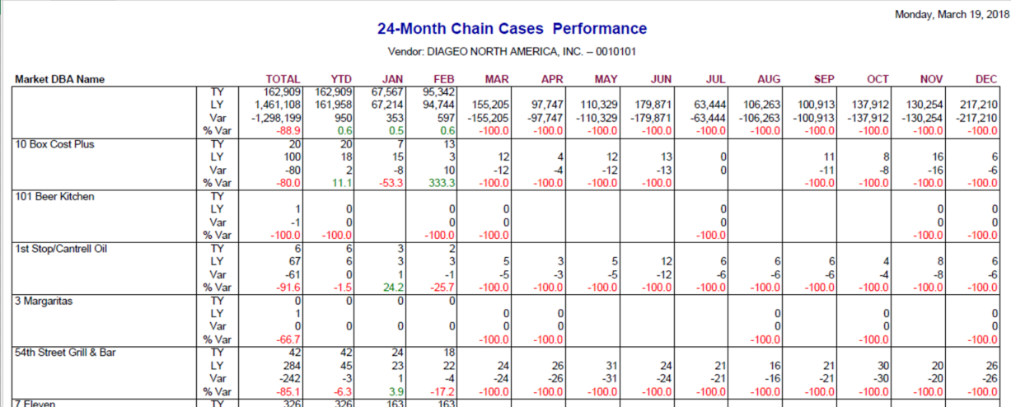

### Case and Bottle Price

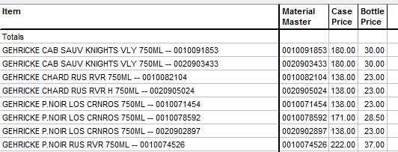

### ZORD_Z04



### MTD Gross Margin



### 3 Month Pricing



### SAP Pricing File

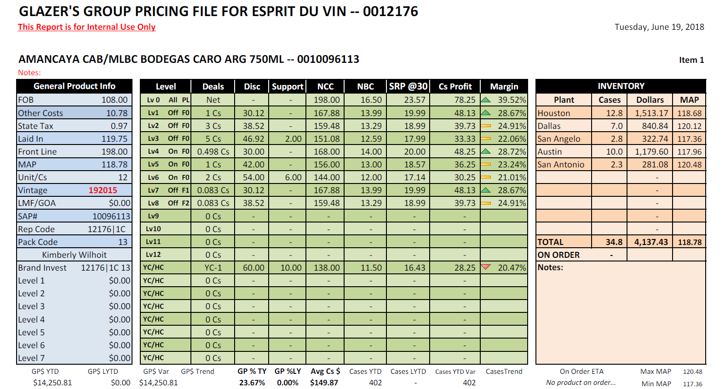

### Pricing Grid

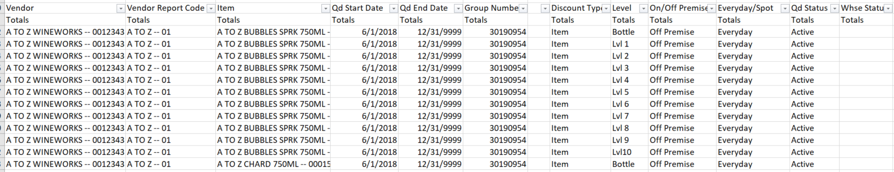

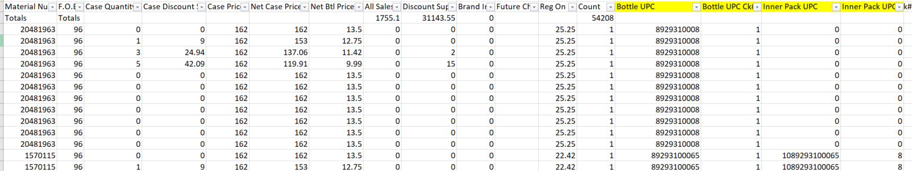

### 12176 Default Pricing (Everyday Discount)

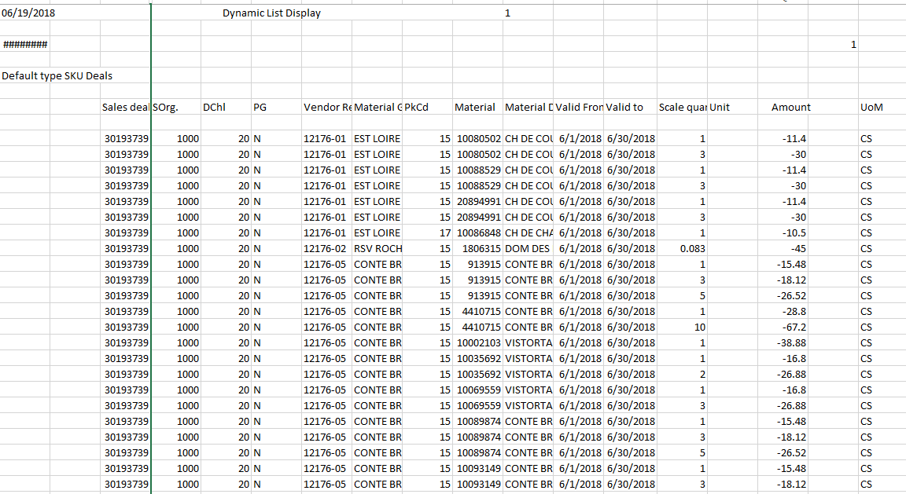

### 12176 Group Pricing (Off-Premise Discount)

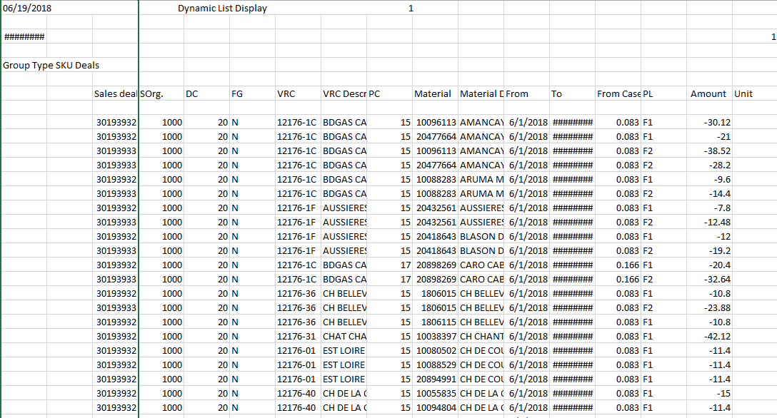

### ZCOST – Margin Report (SAP)

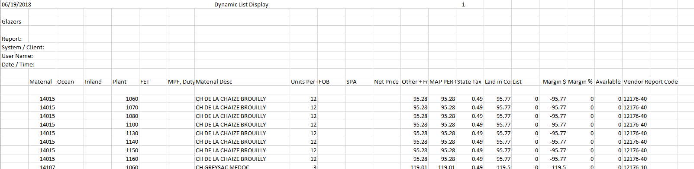

### ZOR101012176 – Support Agreement GOA and BANK Report

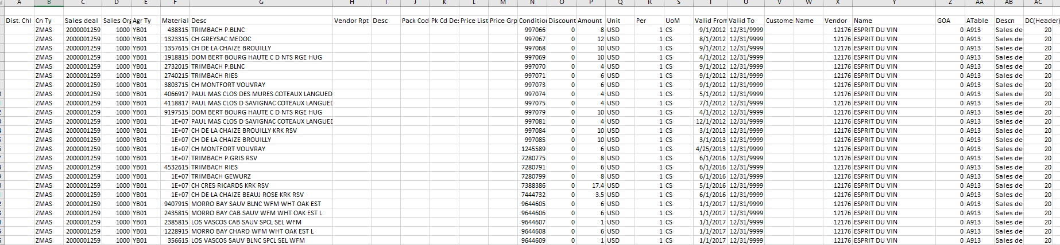

### Order Delivery Report

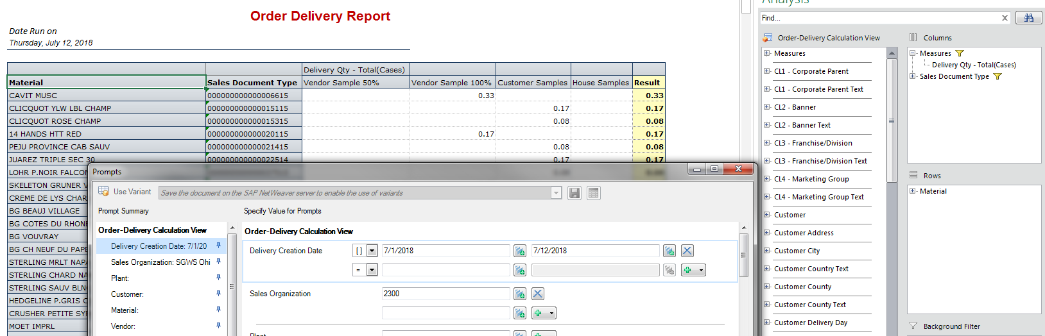

## Data Availability Requests Examples

### Inventory Report

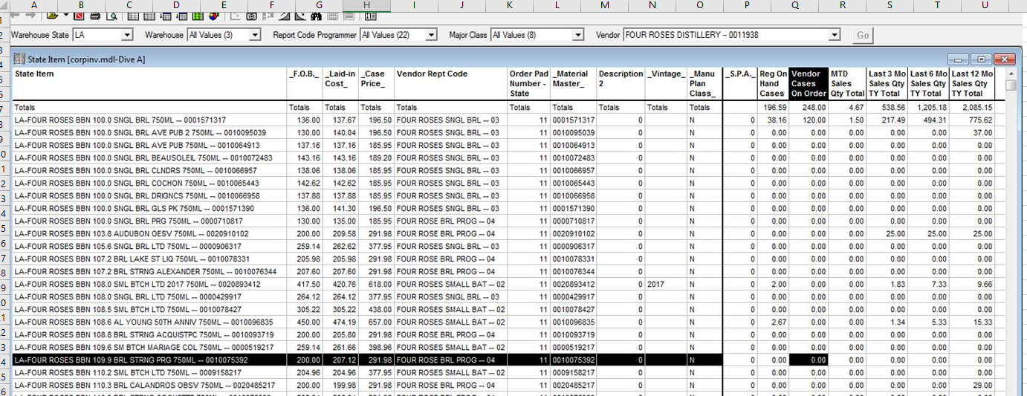

### Gross Profit

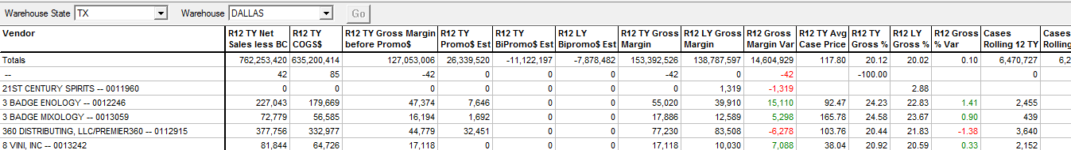

### Salesman Hierarchy

Arkansas Example

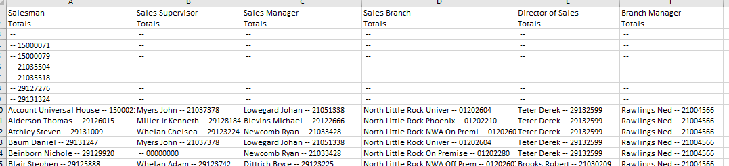

Ohio Example

